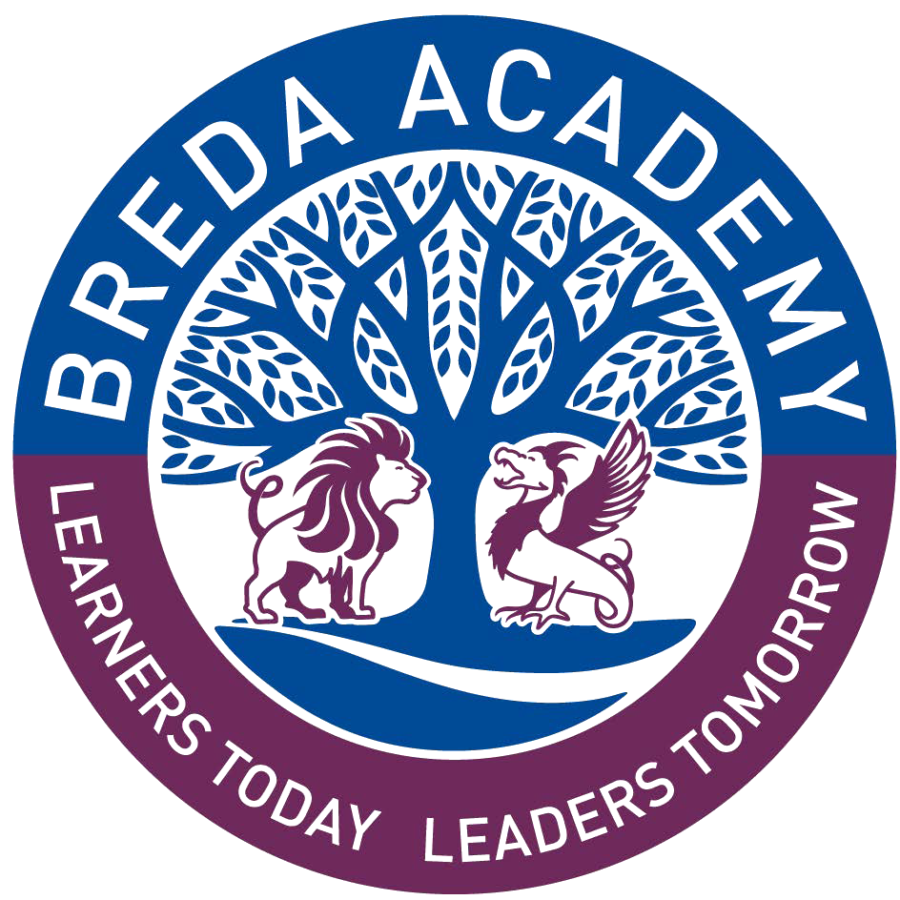

Breda Academy

CHECKLIST

- Submission of documentation and acceptance of place by Monday 5th June 2023
- Log on to the Year 8 Admissions webpage on the Breda Academy website. All paperwork required will be detailed here.

Return by email to dwelsh436@c2ken.net or
Return by post to Admissions, Breda Academy, Newtownbreda Road, Belfast, BT6 8PY

- Student Registration Form (all sections completed and signed)

(Please ensure you include an email contact address as this is our main method of communication)

- Birth certificate (photocopies will be accepted)
(This is a legal requirement by the EA. Please note that postage of originals is at your own risk)

