Dear Parent/Carer

Please send your child to school at the start of the school term with the following Maths equipment.

- Scientific Calculator
- Pen
- Pencil
- Ruler
- Compass
- Protractor
- Rubber
- Sharpener

Yours sincerely

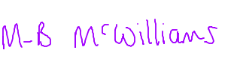

Mrs MB McWilliams
Head of Maths Department

