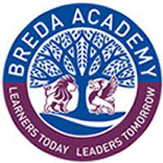
Buses from Breda Academy – return journey at the end of school
Bus 1
Drives along the Dual Carriage way and turns down the Cregagh Road and then along the Woodstock Road.

Bus 2
Drives along the Dual Carriage way and turns down the Cregagh Road.
Turns up Montgomery Road
Turns at Lidl to go towards top of the Castlereagh Road and Clonduff
Then along the Dual Carriageway towards the Braniel
Finally, towards Gilnahirk.

Bus 3
Rosetta and turns onto Mount Merrion.
Ladas Drive and Castlereagh Road, Braniel, Ice Bowl, Dundonald, Ballybeen.

Bus 4
Rosetta – Mount Merrion – Bellsbridge Roundabout – Cregagh Road and then Woodstock Road.

Bus 5
Goes along the carriageway towards Tullycarnet.

Blue Bus 1
Erinvale/ Finagh/ Taughmonagh Bus

