**CAFRE Virtual Open Days**

.

CAFRE will be holding a series of Virtual Open Days which will be broadcast

**LIVE on our DiscoverCAFRE, Facebook page and will begin at 7.00pm sharp**:

**Food** Tuesday 20th October

**Equine** Thursday 22nd October

**Horticulture** Tuesday 3rd November

**Agriculture**  Thursday 5th November

**Land-based Engineering** Tuesday 10th November

**Veterinary Nursing** Wednesday 11th November

**Floristry** Tuesday 17th November

Our LIVE on Facebook events will allow your students and their families to:

* Meet our course teams
* Connect with our students
* Discover our practical facilities
* Explore our campuses
* Link up with our graduates
* Find out about our industry connections, placements and bursaries

*Many thanks for your support, from the CAFRE Education Advisers*

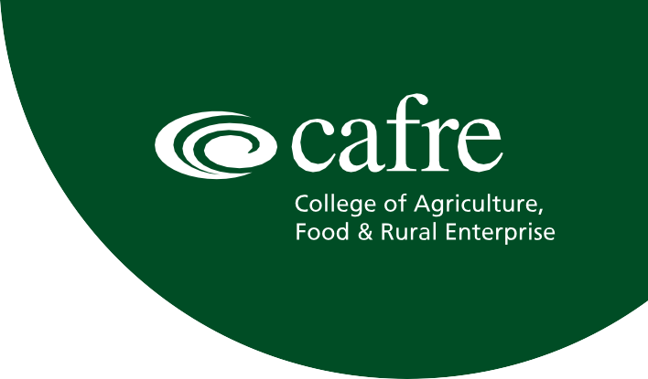

For further information visit:

[**www.cafre.ac.uk**](http://www.cafre.ac.uk/)