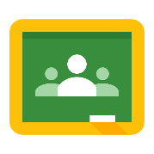
Google Classroom - Logging on
- Click on this link https://classroom.google.com/
or type this web address into the address bar in an internet browser

- Log-on using your C2k details:
- Enter your email address (first initial, surname, three numbers):
For example cmcpeake001@c2ken.net
- The password is the password you use to log-on in school.
- Click ‘Next’
- When the ‘blue screen’ appears, re-enter your C2k email, for example:
- cmcpeake001@c2ken.net
- The password is the password you use to log on in school.
- Click ‘Sign in’

Google Classroom - Joining a Class with your ‘Class Code’
- Click on the ‘+’
- Click ‘Join Class’

- Enter your ‘Class Code’ on the next screen.
- Your class will appear, click on the name (for example Year 11 ICT) to view your school work.

Google Classroom - Joining a Class if you do not have a ‘Class Code’
- Click on this link http://www.c2kschools.net
or type this web address into the address bar in an internet browser
- Type in your C2k username (for example cmcpeake001) and password. Then click the Login button
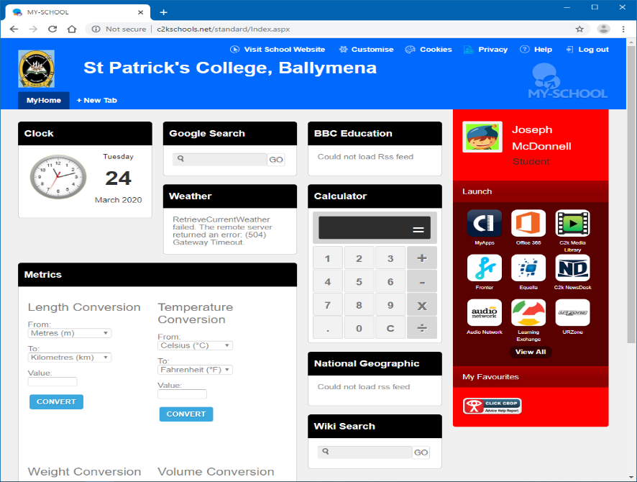
Paddy
Mena

- Your MySchool homepage will load like this picture.
- You can access Google Classroom by clicking on View All

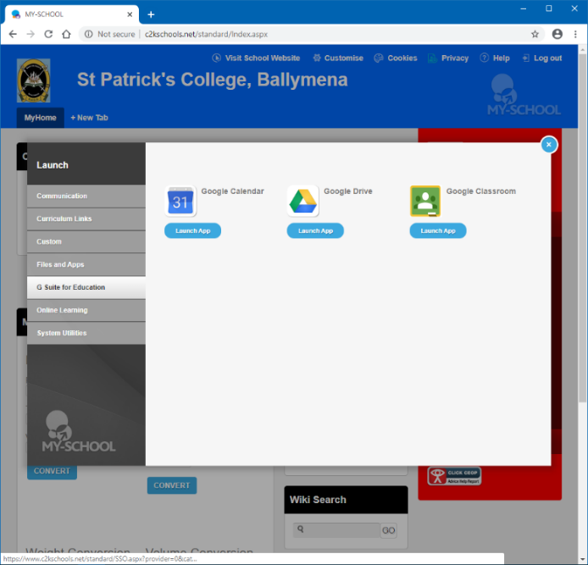
- Click on the G Suite for Education link
- Next, click on the Google Classroom Launch App button
- Continue to log in as shown on Page 1.
- You should now have accessed your Google Classroom.
- If you still cannot access Google Classroom check your school email for a Class Code from your teacher. See instructions on Page 3

Checking School Emails or Sending an Email to a Teacher

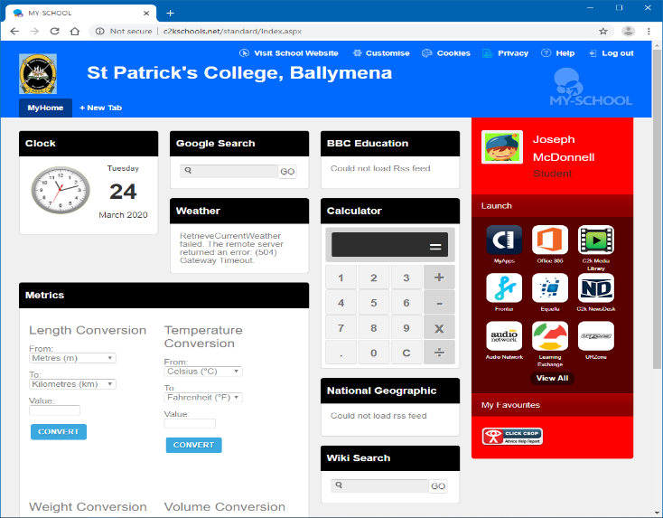
- If you cannot logon to Google Classroom or have a problem you can send your teacher an email.
Paddy
Mena
- Logon to My School as shown on Page 2.
- Access your school email by clicking on Office 365.
- Click on the Outlook icon in the Microsoft Office 365 page.
- Check your email inbox for emails.
- Send an email to your teacher if you have any questions or you need help.

