Microsoft Teams - Logging on
- Click on this link http://www.c2kschools.net
or type this web address into the address bar in an internet browser (Chrome is often the best)

- Type in your C2k username (for example cmcpeake001) and password and click the Login button

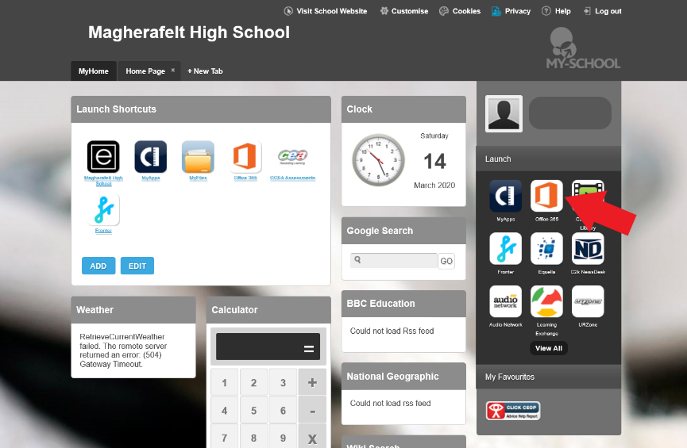

- Your MySchool homepage will load like this picture.
- You can access Microsoft Teams by clicking on Office 365.

- Click on ‘Teams’ from the list of icons.
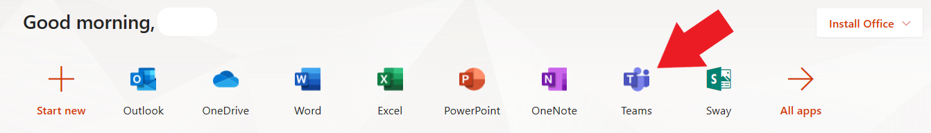

- Go to Teams. You will see all the Teams/Classes you are in.
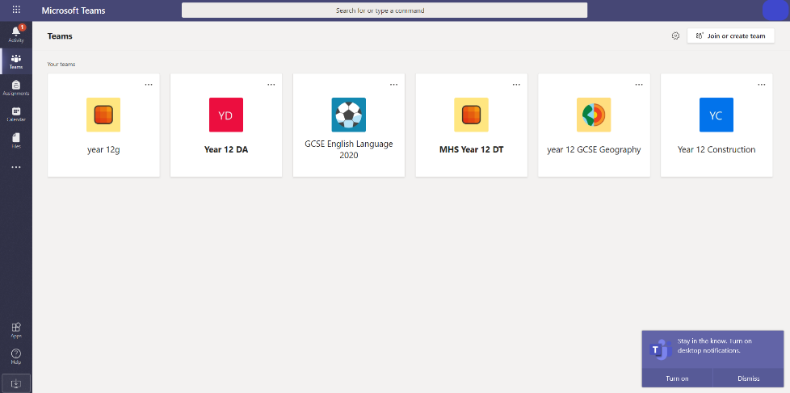

- If you cannot see any Teams, click on ‘Join or Create team’.
You could be asked to enter a Team Code.
The Team Code may be emailed to your school email address.
Use the instructions on the Page 3 to help you check school emails.

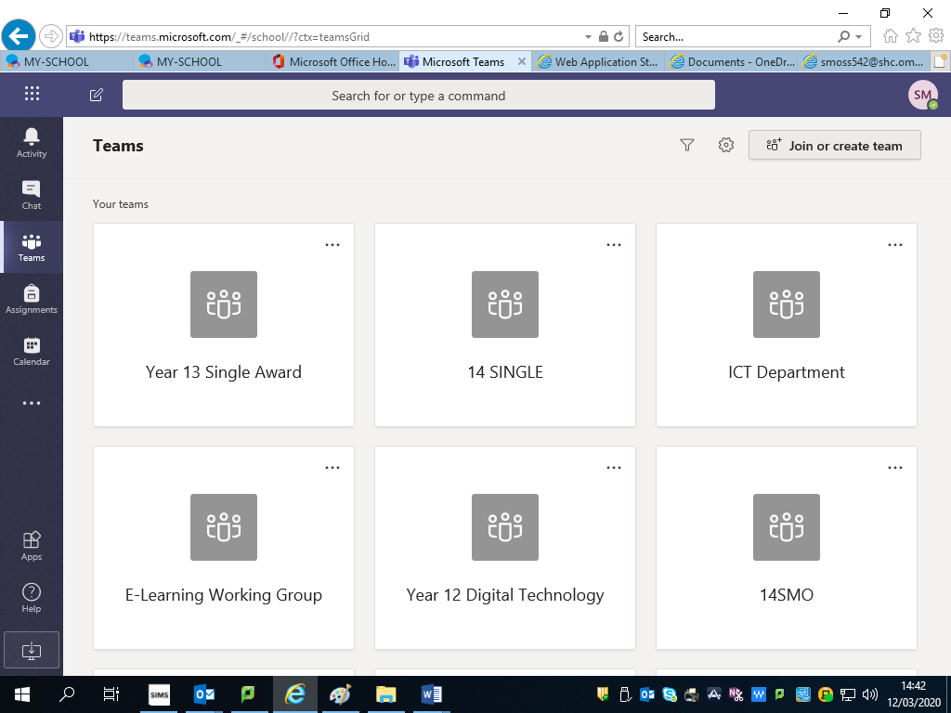

- If you have a class assignment it will appear in the ‘Assignments’ tab.
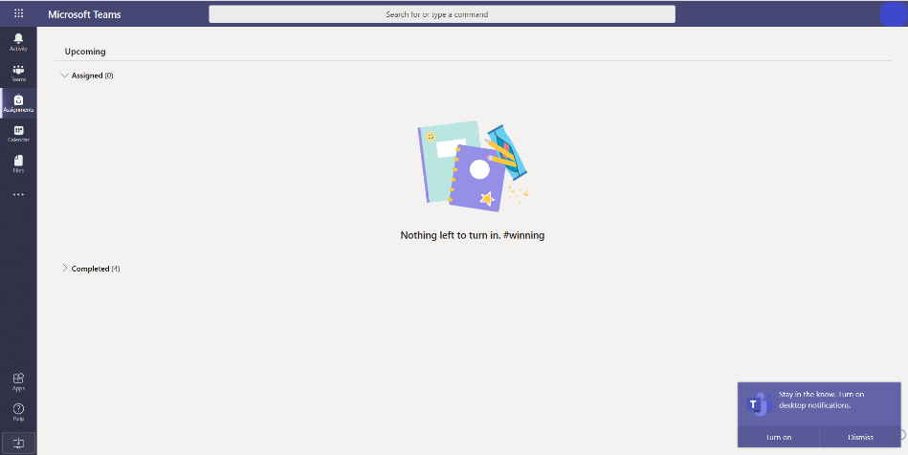

- If you cannot access Teams or you cannot join a Team, send an email to your teacher through your school email (see Page 3).
- Microsoft Teams is also available to download from the Google Play Store (for Android devices) or App Store (iPhone or iPad).

Checking School Emails or Sending an Email to a Teacher

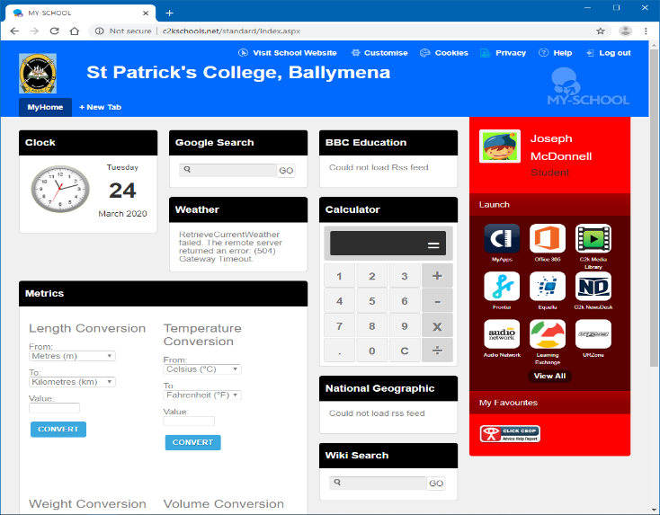
- If you cannot logon to Microsoft Teams or have any problems you can send your teacher an email.
Paddy
Mena
- Logon to My School as shown on Page 1.
- Access your school email by clicking on Office 365.
- Click on the Outlook icon in the Microsoft Office 365 page.
- Check your email inbox for any emails from your teacher.
- Send an email to your teacher if you have any questions or you need help.

Using ‘Immersive Reader’ to Translate Documents
- In any Office 365 application (Word, Excel, etc) you can use ‘Immersive Reader’ to translate documents into different languages.

- Open the document you wish to translate click on ‘View’, then click on ‘Immersive Reader’
- Immersive Reader opens the document in a new browser tab. Click on the book icon in the top right to open up a panel where you can choose your language for translating the document.
- When you have chosen your language you must select ‘Document’ to translate the whole document.

- You can listen to a narrated version by clicking the ‘Play audio’ icon at the bottom of the document.

